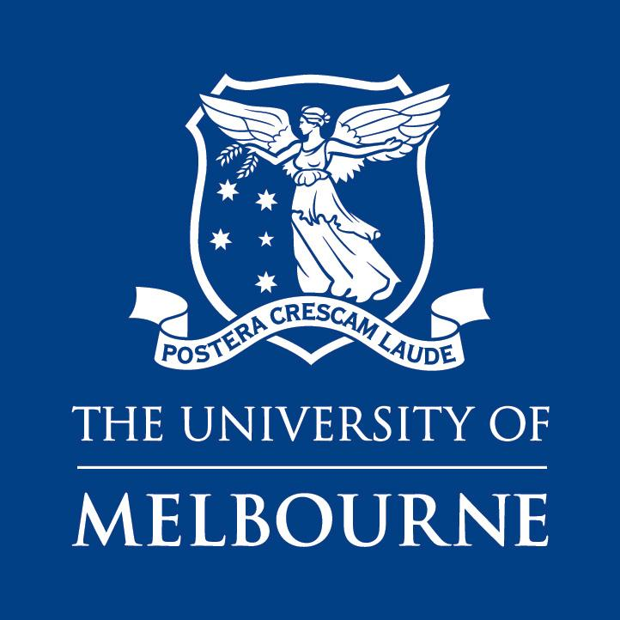

Faculty of Fine Arts and Music

Melbourne Conservatorium of Music
Support for Doctoral Research at the MCM

MCM Music Performance Portfolio Recordings Support Scheme for Doctoral Students

Funding Guidelines and Application Form 2019

The Melbourne Conservatorium of Music Performance Portfolio Recordings Support Scheme assists RHD Doctoral Music Performance students towards the production of their portfolio recordings in their candidature confirmation and for submission in the final examination process.

The MCM employs an in-house audio engineer, Mr Haig Burnell, haigelbagel@senet.com.au, who is available to assist in the production of high-quality audio and video recording files suitable for the examination of the portfolio performance works. No other audio engineer will be considered for MCM funding. Please submit your application to Justin Kenealy, justin.kenealy@unimelb.edu.au, who helps to coordinate the program. Haig should not be approached until an application has been approved for funding.

The total number of hours allocated to each student over their candidature for this is a maximum of 30 hours for the maximum number of minutes of recorded works, that is, 210 minutes of recorded music and a 20,000-word written thesis (or equivalent pro rata reductions in allocations for a portfolio consisting of less recorded music and a longer written thesis). Up to 30% of this time will be available towards the confirmation process. Other variations on this amount of time are to be adjusted accordingly.

Please note: Post-confirmation, the Faculty Small Grant Scheme should be approached in the first instance to support remaining recording costs. This Scheme should also be used for all other costs and activities associated with the portfolio submission: for example, the Conservatorium will fund 6 hours for keyboard accompanists; the FSGS should be approached for paying for extra associate artists, before any requests from this fund are submitted.

Please also be aware that recording free of extraneous noise is only possible at certain times of the year; this normally occurs outside the teaching semesters and practical recital examination weeks.
Doctoral students who seek the assistance of the MCM’s audio engineer must book their studio recording time well in advance of when they wish to record (this is normally at 6-9 months prior to the recording session). Failure to plan ahead will result in funds being withdrawn and future applications being rejected.

Please note:
- In order to ensure that, in line with strict University mandates, students will submit their portfolio in a timely manner, all allotted recording hours must be used within the first three years of candidature. Applications for funding beyond the three years full-time enrolment (or equivalent part-time) will not be considered.
- Recordings must be undertaken using Conservatorium facilities. The use of non-Conservatorium facilities is not allowed, unless approved as part of the application process.
- Retrospective applications for funding will not be considered.

Eligibility
PhD candidates in Performance from the Melbourne Conservatorium of Music are eligible to apply for the Award during the first three years of candidature (or equivalent part-time).
Current students (in the year 2019) may apply for pro rata funding of the first three years of their candidature (FTE): i.e., a full-time candidate, who in 2019 is in their 2nd year, may apply for up to 20 hours over the next two years; a full-time candidate, who in 2019 is in their 3rd year, may apply for up to 10 hours during 2019.

Application process

Student making this application:

Student Number:

Date of Commencement of PhD:

Date of Confirmation into PhD:

Title of PhD:

Total amount of performance repertoire minutes:

Supervisors:

Chair of Advisory Panel:

In no more than one page, in an appendix to this application, provide information that addresses the funding criteria and that is organised according to the following headings:

- Title of PhD
- Background (one paragraph)
- Project Description (repertoire to be recorded, respective durations of works)
- Planned proportions and make-up of PhD:
  - Number of minutes of recorded performances:
  - Number of words for written submission:
- Personnel involved and their roles
- Recording timeline (including exact dates for proposed recordings which must be on campus)
- Details of Faculty Small Grant Scheme allocations (which, again, should be exhausted before applying for assistance from this scheme).

Have you received funding from *FSGS? Yes______ No ______ If so, please give details and amount (in appendix to the Project Description).
I confirm that I have discussed the timing of the recordings with my supervisors. | Y/N

Name of person submitting this application:

Signature Date: __________

Please submit your application and all enquiries to Justin Kenealy justin.kenealy@unimelb.edu.au
who will forward the application for final authorisation* to the Associate Director Research & Research Training.

*please note: this authorisiation has no bearing on the confirmation/conversion to PhD panel outcome.

