

Faculty of Fine Arts and Music

Diversity, Equity, and Inclusion Action Plan 2024-2030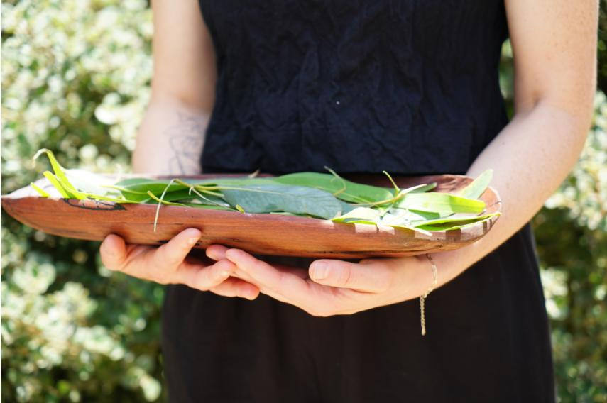

Image: Lecturer in Indigenous Arts and Cultures, Lauren Gower, holds coolamon with leaves as part of the Welcome Ceremony for participants in the 3rd Symposium on Indigenous Arts and Cultures. Photograph by Narida Yeatman-Morgan, Wilin Centre for Indigenous Arts and Cultural Development.

Sensitivity and Care
This document deals with issues of discrimination, inequity, and marginalisation. Sensitivity and care are embedded in the way we work, and the intention is to reflect this in the Diversity, Equity, and Inclusion Action Plan. However, content may be sensitive particularly for those who have experienced or witnessed discrimination. Please prioritise your wellbeing when reading the document. If staff and students of the University of Melbourne experience distress and support is required, we encourage you to contact:
Counselling and Psychological Services (CAPS) (staff and students) and the Employee Assistance Program (EAP) (staff) services.unimelb.edu.au/counsel
+61 3 8344 6927
Safer Community Program safercommunity.unimelb.edu.au
+61 3 8344 6666
Please direct enquiries about the content of the Action Plan to Associate Dean of Diversity, Equity, and Inclusion, Faculty of Fine Arts and Music
fineartsmusic-dei@unimelb.edu.au

Image: Aerial view of Narrm from the surrounds of Southbank Campus looking north. Photograph by Paul Burston.

Table of contents

Acknowledgement of Country and Traditional Owners 6
Message from the Dean, Faculty of Fine Arts and Music 7
Message from Head, Wilin Centre for Indigenous Arts and Culture Development 7
Introduction 8
Purpose 8
Approach 8
Structure of the Action Plan 10
Implementation 11
An embedded approach 11
A responsive approach 11
Governance of the Action Plan 11
Goal 1. All Faculty of Fine Arts and Music students and staff feel included and supported 12
Aim 1.1 To make all spaces and systems accessible, equitable, and inclusive 12
Objective 1.1.1 Improve our buildings and spaces for equitable and inclusive access 12
Objective 1.1.2 Improve our buildings and spaces to support cultural safety, social inclusion, and belonging 13
Objective 1.1.3 Improve digital communication about, in, and from the Faculty of Fine Arts and Music, for equitable and inclusive access 14
Aim 1.2 Improve the experience of staff and students with respect to diversity, equity, and inclusion in the Faculty of Fine Arts and Music 15
Objective 1.2.1 Provide additional resources to staff and students to improve equitable and inclusive processes and practices within the Faculty of Fine Arts and Music 15
Objective 1.2.2 Provide additional resources to students to engage with activities that support diversity, equity, and inclusion in the Faculty of Fine Arts and Music 16
Aim 1.3 Improve teaching and learning to support diversity, equity, and inclusion in the Faculty of Fine Arts and Music 17
Objective 1.3.1 Ensure knowledge, practices, and systems reflect diverse student identities and are accessible to all students 17
Goal 2. The Faculty of Fine Arts and Music community is diverse 18
Aim 2.1 To increase the diversity of our student community 18
Objective 2.1.1 Improve our understanding of diversity in our student community and where increases in diversity are needed 18
Objective 2.1.2 Increase diversity in our student community via a coordinated approach to outreach, recruitment, support, and services 18
Objective 2.1.3 Improve use of data to better support students and future students 19
Aim 2.2 To increase the diversity of our staff community 20
Objective 2.2.1 Increase diversity in our staff community via a coordinated approach to recruitment and support 20
Goal 3. Faculty of Fine Arts and Music meets the expectations of the communities that we serve in relation to diversity, equity, and inclusion 21
Aim 3.1 To better meet the expectations of our staff and student communities in relation to diversity, equity, and inclusion 21
Objective 3.1.1 Embed understanding of the expectations of staff and student communities relating to diversity, equity, and inclusion in faculty planning 21
Objective 3.1.2 Increase opportunity for students and staff with lived experience expertise to inform the work of Faculty of Fine Arts and Music committees and strategic projects 22
Aim 3.2 To better meet the expectations of the broader community in relation to diversity, equity, and inclusion 23
Objective 3.2.1 Embed understanding of the expectations of the broader community relating to diversity, equity, and inclusion, in faculty partnerships and planning 23
Goal 4. Faculty of Fine Arts and Music leadership values diversity and is committed to equity and inclusion 24
Aim 4.1 Faculty of Fine Arts and Music leadership demonstrates commitment to creating diverse, equitable, and inclusive spaces, processes, and community 24
Objective 4.1.1 Increase awareness and recognition of the Faculty of Fine Arts and Music’s commitment to diversity, equity, and inclusion 24
Objective 4.1.2 Faculty of Fine Arts and Music leaders apply a commitment to diversity, equity, and inclusion to decisions and decision-making 25
Aim 4.2 Faculty of Fine Arts and Music leadership actively supports staff and students to contribute to improving diversity, equity, and inclusion 26
Objective 4.2.1 Enable and encourage staff and students to pursue and contribute to the goals, objectives, aims, and actions, of the Diversity, Equity, and Inclusion Action Plan 26
Objective 4.2.2 Recognise service and leadership relating to lived-experience expertise and allyship, in annual performance reviews, promotions, and communications 27

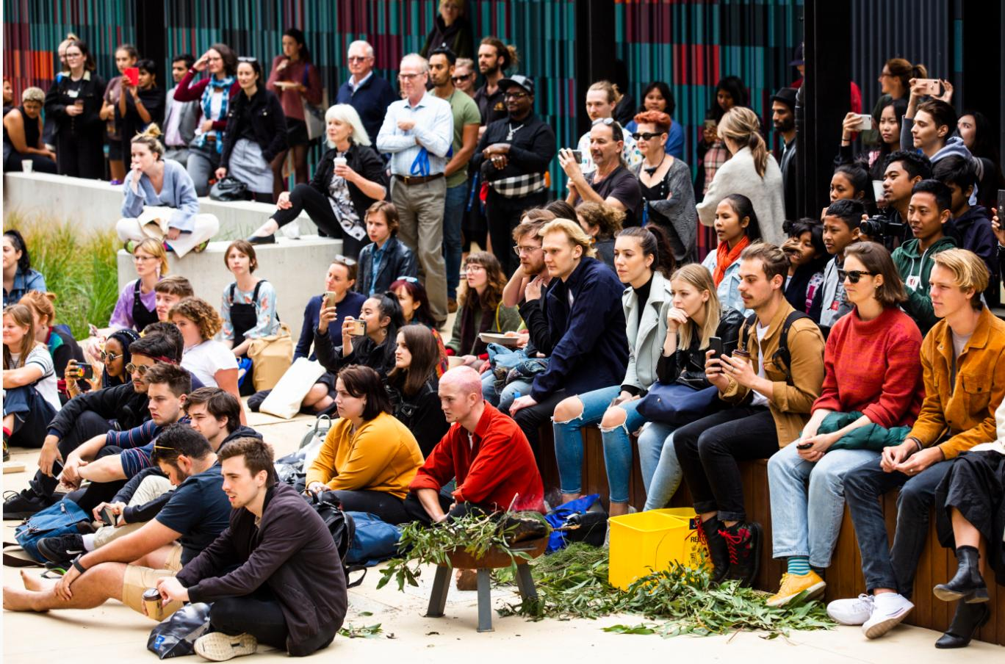
Image: Staff, students, and visitors gather for the Welcome to Country and performances on Orientation Day. Photograph by Drew Echberg.

Acknowledgement of Country and Traditional Owners
The University of Melbourne acknowledges the Traditional Owners of the unceded land on which we work, learn and live: the Wurundjeri Woi-wurrung and Bunurong peoples (Burnley, Fishermans Bend, Parkville, Southbank and Werribee campuses), the Yorta Yorta Nation (Dookie and Shepparton campuses), and the Dja Dja Wurrung people (Creswick campus).
The University also acknowledges and is grateful to the Traditional Owners, Elders and Knowledge Holders of all Indigenous nations and clans who have been instrumental in our reconciliation journey.
We recognise the unique place held by Aboriginal and Torres Strait Islander peoples as the original owners and custodians of the lands and waterways across the Australian continent, with histories of continuous connection dating back more than 60,000 years. We also acknowledge their enduring cultural practices of caring for Country.
We pay respect to Elders past, present and future, and acknowledge the importance of Indigenous knowledges in the Academy. As a community of researchers, teachers, professional staff and students we are privileged to work and learn every day with Indigenous colleagues and partners.
In making this Acknowledgment of Country we commit to respectful and responsible conduct towards all others according to the Traditional lores of this land, particularly at times of formal ceremony .
At the Faculty of Fine Arts and Music, we also acknowledge that we practice our art, research, and teaching and learning, on unceded lands, where songs have been sung, dances have been danced, and knowledge produced, transmitted, taught, and learnt, for thousands of generations. We pay respect to Elders past, present, and future, and acknowledge the importance of Indigenous knowledge in the academy and society. As a community of researchers, teachers, professional staff, and students, we are privileged to work with and learn from Indigenous colleagues and partners every day.

Message from the Dean, Faculty of Fine Arts and Music
The Faculty of Fine Arts and Music is committed to positive change in relation to diversity, equity, and inclusion and creating a thriving place for all members of our community.
Since the endorsement of the University’s Diversity and Inclusion Strategy in 2021, the Faculty Diversity, Equity, and Inclusion Committee has consulted with students and staff to deliver the first Diversity, Equity, and Inclusion Action Plan for Fine Arts and Music. It is bold, aspirational, and grounded in actions to create impactful and sustainable change.
The Action Plan is distinctive to the Faculty’s place in society, and we believe that the arts are critical to the sustainability of societies globally. To enable that sustainability, we need diversity among our communities, including through a range of artistic, creative, and scholarly expressions, with these supported by equitable and inclusive systems, processes, and spaces.
A distinctive element of the Action Plan is embedding First Nation’s authority and leadership in inclusive practice. We centre much of our work in professional development training, teaching/learning, research, and support provided by the Wilin Centre for Indigenous Arts and Cultural Development.
As you read through the Action Plan, we hope that you will see that this is an all-of-Faculty commitment, with significant responsibility carried by leadership to implement the work in all areas of Faculty governance and planning.
Marie Sierra
October, 2024

Message from Head, Wilin Centre for Indigenous Arts and Culture Development
For tens of thousands of years, the land occupied by the Faculty of Fine Arts and Music has been a place of meeting and celebration for the peoples of the Kulin Nations. Within these Boonwurrung and Wurundjeri Woi-Wurrung lands, communities of practice have come together from across Kulin Country and beyond to build stronger communities and revel in the strength that comes from telling one another’s stories.
Just over two decades ago the Wilin Centre for Indigenous Arts and Cultural Development was established under the guidance of Elders and Traditional Owners who speak for this Country. he Wilin Centre was founded with a very basic belief at its heart – that our institution and our society needed the voices of the First Nations creatives who might otherwise not pursue study because places like
the VCA and MCM were “not for them”. This is not because there is some Machiavellian villain who lives within these walls, spitefully trying to suppress Indigenous peoples. Rather, it is because we all live with the legacy and frameworks of an unjust past which has historically excluded the voices of those who are considered “other”. In this regard, such an experience is not held exclusively by First Peoples. Many of the stories that we need to thrive and survive as creatives have been kept from us in this place. Regardless of our background, we can seize this opportunity to look to what we’ve missed in the past to make our future brighter.
It is my fervent hope that in embracing and amplifying our Diversity, Equity, and Inclusion Action Plan, we can further the wonderful work being done by so many within our community. Work which draws upon the laws, principles, and diplomacies which have guided art making in these lands for thousands upon thousands of generations and which acknowledge a fundamental truth – our stories are stronger when we tell them together.
Tiriki Onus
October, 2024

Introduction

Purpose
The Diversity, Equity, and Inclusion Action Plan 2024 – 2030 (‘the Action Plan’) is the first action plan for diversity, equity, and inclusion for the Faculty of Fine Arts and Music. The Action Plan responds strategically to the need for systemic transformation so that all students, staff, and members of the broader community, can access and have positive experiences in our spaces and with our people, programs, and systems. It responds to needs identified in a suite of University strategies and action plans. It responds to data from a range of surveys and reports that reveal inequitable experiences within our faculty, as well as from insights shared in consultation for and feedback on the Action Plan. Our response recognises that we must act in the interests of fairness and justice for our current and future people. Our response is also distinctive to our faculty’s place in the world, insofar as diversity in the arts is critical to the sustainability of society; to enable diversity, we need equitable and inclusive practices, processes, systems, and spaces.
The Action Plan will impact all in our community. We take the position that diversity is a strength in the arts and that success requires that all are supported to work together to transform our places and practices. Accordingly, all staff and students will find Actions that are applicable to their activity, whether that be work in professional roles, and/or across academic domains of teaching and learning, research, and leadership.
The Action Plan has been specifically designed to improve how we welcome and support people who have been inequitably prevented from participating fully. This includes: staff, students, and visitors with disability, and carers; staff, students, and visitors who experience discrimination based on culture, ethnicity, language, nationality, and/or due to racism; First Nations staff, students, and visitors; LGBTIQA+ students, staff, and visitors to the University; and those who experience discrimination based on gender. Our approach recognises that individuals face cumulative disadvantage, and that not all experiences of disadvantage are apparent.

Approach
Importantly, we recognise that our faculty sits on unceded Boonwurrung/Bunurong and Woi Wurrung Wurundjeri Lands across the Southbank and Parkville campuses, and that our activities are conducted on the Lands of First Nations and Indigenous Peoples across the continent and beyond. We recognise that the colonial regime has targeted the expression and teaching of arts practices and knowledges, in attempts to control First Nations Lands and Peoples. Echoing the University’s Anti-Racism Action Plan, we recognise that the University and our disciplines have been shaped by these legacies, as well as by the racist attitudes and legislation that further limited cultural and racial diversity in Australia. We recognise that settler racism and exclusion continue in day-to-day interactions, systems, and processes. We recognise that proposing a strategy to address equity in our faculty, as we do in this Action Plan, is therefore fraught.
We proceed recognising that within First Nations communities is long-standing expertise in what must be done to improve our systems and processes in the interests of equity and inclusivity. Our approach to improving diversity, equity, and inclusion in our faculty, is therefore closely integrated with the work of the faculty’s Wilin Centre for Indigenous Arts and Cultural Development, as are the values of Humility, Commitment, Accountability, Respect, and Reciprocity, that are laid out in the University’s Murmuk Djerring Indigenous Strategy.
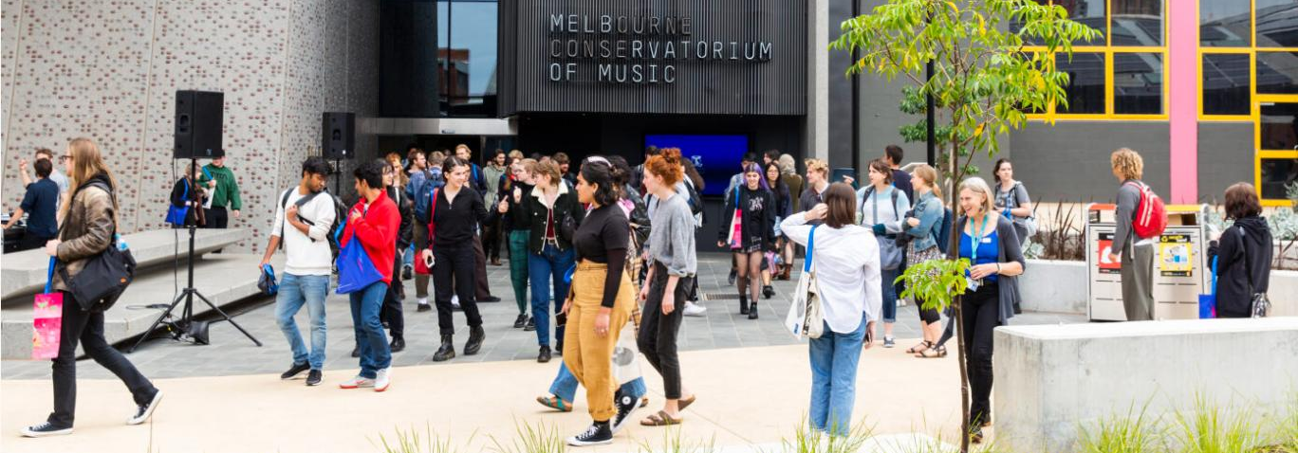
Image: Students outside the Ian Potter Southbank Centre, Melbourne Conservatorium of Music, on Orientation Day. Photograph by Drew Echberg, 2020.
Diversity refers to our commitment to recognise, embrace and increase the representation of different groups and individuals at the University. Diversity at the University of Melbourne means respecting the breadth and range of experience, perspective and knowledge that our staff and students bring to our University community. As a public institution we embrace diversity across our student and staff bodies, and across all roles and functions, to represent, reflect and serve our community. We aim to work with partners who similarly prioritise this objective.
Inclusion refers to our practices that support and embody fairness, safety and equality of opportunity to ensure the full participation and advancement of all individuals and groups. Inclusion at the University of Melbourne is about the systems and practices that create a welcoming and respectful University environment where all members of our community can fully participate, thrive and belong. This supports principles of justice and fairness and meets our duty of care to our staff, students and partners. Meaningful inclusion supports the success of all community members through the realisation of their full potential and thus supports the pursuit of excellence in everything we do.
What diversity and inclusion means at the University of Melbourne, Diversity and Inclusion Strategy 2030, p.6.

Equity at the University of Melbourne refers to our commitment to pursue diversity and inclusion across all our spaces, systems, and practices, so that all are supported to fulfil their aspirations, recognising people face inequitable barriers to doing so. Equity is embedded in multiple strategies and documents at the University of Melbourne, including the Diversity and Inclusion Strategy 2030, the Advancing Students in Education strategy, Murmuk Djerring and the People Strategy, as well as various Action Plans.

Structure of the Action Plan
Four Goals are identified in the Action Plan. These Goals respond to evidenced need and signal our commitment to continually improve diversity, equity, and inclusion in our faculty.
Goal 1 | All Faculty of Fine Arts and Music students and staff feel included and supported.
Goal 2 | The Faculty of Fine Arts and Music community is diverse.
Goal 3 | The Faculty of Fine Arts and Music meets the expectations of the communities that we serve in relation to diversity, equity, and inclusion.
Goal 4 | The Faculty of Fine Arts and Music leadership values diversity and is committed to equity and inclusion.

Four roles to support implementation have been identified for each Action
Role | Role description
Sponsor | The Action Sponsor is the person or position that has ultimate accountability for the Action and, where relevant, its carriage through faculty governance.
Lead | The Action Lead is the person or position that is responsible for ensuring the Action reaches completion.
Supported by | The ‘Supported by’ role is the person or people, team(s), position(s), and committee(s) that are responsible for supporting the progress and completion of the Action.
Others to be consulted | The ‘Others to be consulted’ role is the person or people, team(s), position(s), and committee(s) that will be consulted in the development and/or carrying out of Actions, and/or included in co-design of aspects of Action work.

Critical to moving towards these Goals are a set of Aims and Objectives, with associated Actions, identified for a three-year period.
Item | Explanation
Goals | The overarching aspirations that guide our commitments.
Aims | The key changes that we pursue, in relation to Goals.
Objectives | The outcomes that we pursue, in relation to the Aims.
Actions | The critical work that we will deliver, in relation to Objectives, Aims, and towards our Goals.

Prioritisation of Actions has been informed by consideration of: evidence of need; alignment with University and/or faculty strategy; impact on staff and/or students; as well as feasibility in relation to project scale, state of work, staff workload and workforce planning, and related dependencies.

Implementation

An embedded approach
The need for the faculty to demonstrate accountability to our staff and student community, in relation to action to improve diversity, equity, and inclusion, was emphasised in the evidence base for this Action Plan. Our staff and students want to be informed of, and have input into, actions for change. Trust is similarly identified as a goal in the University Diversity and Inclusion Strategy 2030. Accordingly, implementation is embedded in the design of the Action Plan to create meaningful systemic change.
Consultation, engagement, and communication across our staff and student community, are embedded across all Actions.
Monitoring, review, and reporting on the efficacy of our Actions in relation to our Goals, are named as Actions.
Our progress and emerging recommendations will inform the Faculty Business Plan, the annual review of which will coincide with review and re-release of the Action Plan

A responsive approach
A new edition of the Action Plan will be issued in 2025 and in each subsequent year. In each edition of the Action Plan, some Actions will continue, some may be updated or reprioritised, and some new Actions may be identified where there is evidence of emerging need. This structure will ensure that the Actions for a given period
respond to the dynamic needs of the faculty, are relevant to strategic projects in the faculty, and are aligned with University strategies and related work. It will allow for refinement of the organisation of the Action Plan as outcomes are realised, and for specific targets and measures to be articulated as we progress our work.
Timing of review and renewal | Diversity, Equity, and Inclusion Action Plan (DEIAP) documents
Semester 2, 2024 | DEIAP Version 1, 2024 – 2026
Semester 2, 2025 | DEIAP Version 2, 2025 – 2027
Semester 2, 2026 | DEIAP Version 3, 2026 – 2028
Semester 2, 2027 | DEIAP Version 4, 2027 – 2029
Semester 2, 2028 | DEIAP Version 5, 2028 – 2030
Semester 2, 2029 | DEIAP Version 6, 2029 – 2030

Governance of the Action Plan
Action Sponsors and Project Leads carry primary responsibility for the carriage and conduct of Action work. The Diversity, Equity, and Inclusion Committee, chaired by the Associate Dean of Diversity, Equity, and Inclusion, will ensure progress is supported and monitored in relation to Aims, Objectives, and Goals, and that work aligns with Faculty and University developments in the space. The Committee and Associate Dean will direct recommendations and reports to Faculty Executive for discussion and decision, where necessary. With the Faculty Office, the Committee and Associate Dean will lead reporting to the faculty community and support annual faculty planning cycles.

Goal 1. All Faculty of Fine Arts and Music students and staff feel included and supported

Aim 1.1 To make all spaces and systems accessible, equitable, and inclusive

Objective 1.1.1 Improve our buildings and spaces for equitable and inclusive access
Action Number | Action | 24 | 25 | 26 | Sponsor | Lead | Supported by | Others to be consulted
1.1.1.1 | Develop Faculty of Fine  Arts and Music Accessibility  Masterplan |  | 25 |  | Faculty Executive Director | Senior Manager,  Programs and  Operations | Manager, Health, Safety and Risk; Manager, Resources and Facilities | Associate Dean, Diversity, Equity, and Inclusion, and committee; Associate Dean, Student Wellbeing; Student Support Reference Group; Student Equity and Disability Services; staff and students with lived experience expertise; sources of subject matter expertise
1.1.1.2 | Continue works on and maintenance of buildings and spaces to improve equitable and inclusive access | 24 | 25 | 26 | Faculty Executive Director | Senior Manager,  Programs and  Operations | Campus Services;  Manager, Health, Safety and Risk; Manager,  Resources and Facilities | Associate Dean, Diversity, Equity, and Inclusion, and committee; Associate Dean, Student Wellbeing; Student Support Reference Group; Academic Support Office; Student Equity and Disability Services; staff and students with lived experience expertise; sources of subject matter expertise
1.1.1.3 | Improve processes for staff and students to report issues relating to equitable and inclusive access to buildings and spaces, and processes  for the faculty to report on responses and related works |  | 25 |  | Faculty Executive Director | Senior Manager,  Programs and  Operations | University  Communications &  Marketing; Campus  Services; Manager  Strategic Initiatives;  Academic Support Office | Associate Dean, Diversity, Equity, and Inclusion, and committee; Student Equity and Disability Services; staff and students with lived experience expertise; sources of subject matter expertise

Objective 1.1.2 Improve our buildings and spaces to support cultural safety, social inclusion, and belonging
Action Number | Action | 24 | 25 | 26 | Sponsor | Lead | Supported by | Others to be consulted
1.1.2.1 | Develop a student hub for wellbeing services, and increase provision of culturally safe services | 24 | 25 | 26 | Associate Dean,  Student Wellbeing | Manager, Resources and  Facilities | Infrastructure Services; Student and Scholarly Services | Head, Wilin Centre; Associate Dean, Diversity, Equity, and Inclusion, and committee; Student Support Reference Group; University of Melbourne Student Union; Graduate Student Association; staff and students with lived experience expertise; sources of subject matter expertise
1.1.2.2 | Increase spaces for social gathering and food accessibility on  the Southbank campus, including prioritisation of campus cafeteria |  |  | 26 | Faculty Executive  Director | Senior Manager,  Programs and  Operations | Academic Support Office – Student  Experience  Coordinator | Directors, VCA and MCM; Student Support Reference Group; University of Melbourne Student Union; Graduate Student Association
1.1.2.3 | Review and improve provision of quiet spaces across Southbank campus and Melba Hall Music Building |  | 25 | 26 | Faculty Executive  Director | Senior Manager,  Programs and  Operations | Associate Dean, Student Wellbeing | Associate Dean, Diversity, Equity, and Inclusion, and committee; Student Support Reference Group; staff and students with lived experience expertise; sources of subject matter expertise
1.1.2.4 | Identify opportunities to ensure that diversity in our staff, student, and wider communities is reflected in the physical environment  of the campus and in programming |  | 25 | 26 | Faculty Executive  Director | Senior Manager,  Programs and  Operations | Directors, VCA and MCM; Associate Dean, Diversity, Equity and Inclusion and committee; Head, Wilin Centre; Associate Dean, International | Head, Wilin Centre; Student Support Reference Group; University of Melbourne Student Union; Graduate Student Association; First Nations staff and students; other staff and students with lived experience expertise; sources of subject matter expertise

Objective 1.1.3 Improve digital communication about, in, and from the Faculty of Fine Arts and Music, for equitable and inclusive access
Action Number | Action | 24 | 25 | 26 | Sponsor | Lead | Supported by | Others to be consulted
1.1.3.1 | Develop and implement a First Nations gateway to the Faculty of Fine Arts and Music website, within a larger First Nations communications plan | 24 | 25 | 26 | Head, Wilin Centre | Senior Manager,  Academic Support Office | University Communications & Marketing; Manager, Strategic Initiatives | Faculty of Fine Arts and Music Indigenous Academic Staff Network; First Nations staff and students; First Nations community advisors
1.1.3.2 | Review and revise Faculty of Fine Arts and Music webpages to increase accessibility and inclusiveness of language and design |  | 25 |  | Associate Dean, Diversity, Equity, and  Inclusion | Faculty Office | University Communications & Marketing; Diversity, Equity, and Inclusion Committee; Head, Wilin Centre | Student Support Reference Group; Student Equity and Disability Support; staff and students with lived experience; sources of subject matter expertise
1.1.3.3 | Provide staff with resources for accessible and inclusive language and tools for use across all digital communications, including webpages, newsletters, digital documents, and email communications |  | 25 |  | Associate Dean, Diversity, Equity, and  Inclusion | Faculty Office | University Communications & Marketing; Diversity, Equity, and Inclusion Committee; Associate Dean, International; Head, Wilin Centre | Associate Dean, Academic; Manager, Research Office; Student Support Reference Group; staff and students with lived experience; sources of subject matter expertise

Aim 1.2 Improve the experience of staff and students with respect to diversity, equity, and inclusion in the Faculty of Fine Arts and Music

Objective 1.2.1 Provide additional resources to staff and students to improve equitable and inclusive processes and practices within the Faculty of Fine Arts and Music
Action Number | Action | 24 | 25 | 26 | Sponsor | Lead | Supported by | Others to be consulted
1.2.1.1 | Extend the Wilin Centre’s professional development program and develop resources for culturally inclusive  and responsive practices across the faculty, aligned with University Diversity and Inclusion Action Plans | 24 | 25 | 26 | Dean | Head, Wilin  Centre; Associate  Dean, Diversity,  Equity, and  Inclusion | Faculty Executive Director; Human Resources; Associate Dean, Academic; Associate  Dean, Research; Associate Dean, International; Associate Dean, Student Wellbeing; Directors, MCM and VCA; Academic Support Office; Inclusion and Accessibility Advisors | Diversity, Equity, and Inclusion Committee; Student Support Reference Group; Manager, Risk and Safety; Scholarly and Student Services; staff and students with lived experience; sources of subject matter expertise
1.2.1.2 | Establish an inclusion and accessibility advisor program, supported by  the Wilin Centre’s professional development program, and aligned with University Diversity and Inclusion Action Plans |  | 25 | 26 | Dean | Associate Dean,  Diversity, Equity,  and Inclusion;  Senior Manager,  Academic  Support Office | Directors, MCM and VCA; Faculty Executive Director; Human Resources; Head, Wilin Centre; Associate Dean, Academic; Associate Dean, Research; Associate Dean, International;  Associate Dean, Student Wellbeing; Academic Support Office | Diversity, Equity, and Inclusion Committee; Student Support Reference Group; Manager, Risk and Safety; Scholarly and Student Services; staff and students with lived experience; sources of subject matter expertise
1.2.1.3 | Provide staff and students with resources to aid triaging and managing concerns and issues relating to diversity, equity, and inclusion | 24 | 25 |  | Faculty Executive Director | Senior Manager,  Academic  Support Office;  Head, Wilin  Centre | Scholarly and Student Services; Manager, Risk and Safety; Directors, VCA and MCM | Diversity, Equity, and Inclusion Committee; Student Support Reference Group; Human Resources

Objective 1.2.2 Provide additional resources to students to engage with activities that support diversity, equity, and inclusion in the Faculty of Fine Arts and Music
Action Number | Action | 24 | 25 | 26 | Sponsor | Lead | Supported by | Others to be consulted
1.2.2.1 | Increase opportunities and support for students to engage in and lead initiatives that support community-building and improve understanding in relation to diversity, equity, and inclusion, aligned with Wilin’s professional development training program |  | 25 | 26 | Associate Dean, Student Wellbeing | Senior Manager,  Academic Support Office | Head, Wilin Centre; Directors, VCA and MCM; Associate Dean, Diversity, Equity and Inclusion and committee; Associate Dean, International; Student and Scholarly Services; Academic Support Office | Diversity, Equity, and Inclusion Committee; Coordinator, MCM Ignite Lab; Student Support Reference Group
1.2.2.1 | Develop and maintain Faculty of Fine Arts and Music webpages that promote and improve accessibility of global and local experience opportunities, internships, and other programs |  | 25 |  | Associate Dean,  International | Senior Manager,  Academic Support Office | University Communications and Marketing; International Committee; Student Experience Coordinator, Academic Support Office; Senior Manager, Research Office | Directors, VCA and MCM; Faculty of Fine Arts and Music Work-integrated Learning Lead; MCM Ignite Lab

Aim 1.3 Improve teaching and learning to support diversity, equity, and inclusion in the Faculty of Fine Arts and Music

Objective 1.3.1 Ensure knowledge, practices, and systems reflect diverse student identities and are accessible to all students
Action Number | Action | 24 | 25 | 26 | Sponsor | Lead | Supported by | Others to be consulted
1.3.1.1 | Establish a Working Group for diversity, equity, and inclusion in teaching and learning, and in graduate research training |  | 25 | 26 | Associate Dean,  Academic | Directors, VCA  and MCM | Head, Wilin Centre; Associate Dean, Diversity, Equity, and Inclusion; Associate Dean, Research; Senior Manager, Research Office; Associate Dean, International; Academic Support Office; Chair, Library Committee; Southbank Library | Student and Scholarly Services; staff and students with lived experience expertise; sources of subject matter expertise
1.3.1.2 | Re-establish the Working Group for Indigenising the curriculum, aligned with the Wilin Centre's professional development program |  | 25 | 26 | Associate Dean, Academic | Head, Wilin Centre | Directors, VCA and MCM; Associate Dean, Diversity, Equity, and Inclusion; Associate Dean, International; Associate Dean, International; Academic Support Office; Chair, Library Committee; Southbank Library | First Nations staff and students; Wilin Centre; sources of subject matter expertise

Goal 2. The Faculty of Fine Arts and Music community is diverse

Aim 2.1 To increase the diversity of our student community

Objective 2.1.1 Improve our understanding of diversity in our student community and where increases in diversity are needed
Action Number | Action | 24 | 25 | 26 | Sponsor | Lead | Supported by | Others to be consulted
2.1.1.1 | Monitor underrepresentation  within the student population  in relation to diversity | 24 | 25 | 26 | Senior Manager, ASO | Manager, Strategic  Initiatives | Manager, Academic Support Office; Senior Manager, Research Office; University Data Analyst | Associate Dean, Diversity, Equity, and Inclusion, and committee; University of Melbourne Student Union; Graduate Student Association

Objective 2.1.2 Increase diversity in our student community via a coordinated approach to outreach, recruitment, support, and services
Action Number | Action | 24 | 25 | 26 | Sponsor | Lead | Supported by | Others to be consulted
2.1.2.1 | Develop and roll out the Widening Participation initiative, to target all areas of underrepresentation in  alignment with the Anti-Racism Action Plan | 24 | 25 | 26 | Directors VCA and MCM | Manager, Strategic  Initiatives | Senior Manager, Academic Support Office; Student and Scholarly Services; Associate Dean, Diversity, Equity, and Inclusion | Head, Wilin Centre; Coordinator, MCM Ignite Lab; Senior Manager, Research Office; Inclusion and Accessibility Advisors; Wilin Centre; Scholarships; Advancement; University of Melbourne Student Union; Graduate Student Association; staff and students with lived experience expertise; sources of subject matter expertise

Objective 2.1.3 Improve use of data to better support students and future students
Action Number | Action | 24 | 25 | 26 | Sponsor | Lead | Supported by | Others to be consulted
2.1.3.1 | Improve how we collect and use data to ensure our application and selection processes are accessible to all | 24 | 25 |  | Senior Manager,  Academic Support Office | Manager, Academic  Support Office | Student and Scholarly Services; Head, Wilin Centre; Manager, Strategic Initiatives (Widening Participation); Associate Dean, Diversity, Equity, and Inclusion | Diversity, Equity, and Inclusion committee; Faculty Office
2.1.3.2 | Improve how we provide students with information about support relating to accessibility and equity in the Faculty of Fine Arts and Music throughout their candidature |  | 25 | 26 | Senior Manager,  Academic Support Office | Manager, Academic  Support Office | Student and Scholarly Services; Head, Wilin Centre; Manager, Strategic Initiatives (Widening Participation); Associate Dean, Student Wellbeing; Associate Dean, Diversity, Equity, and Inclusion | Inclusion and Accessibility Advisors; Wilin Centre; Faculty Work Integrated Learning coordinator; Associate Dean, International; Student Support Reference Group; University of Melbourne Student Union; Graduate Student Association; students with lived experience expertise

Aim 2.2 To increase the diversity of our staff community

Objective 2.2.1 Increase diversity in our staff community via a coordinated approach to recruitment and support
Action Number | Action | 24 | 25 | 26 | Sponsor | Lead | Supported by | Others to be consulted
2.2.1.1 | Identify where and what information about staff diversity in the Faculty of Fine Arts and Music is recorded and fill gaps in knowledge |  | 25 | 26 | Faculty Executive  Director | Faculty Office | Human Resources; Associate Dean, Diversity, Equity, and Inclusion; University Data Analyst | Inclusion and Accessibility Advisors; Wilin Centre; staff with lived experience expertise; sources of subject matter expertise
2.2.1.2 | Implement inclusive  recruitment practices | 24 | 25 | 26 | Faculty Executive  Director | Faculty Office | Human Resources; Associate Dean, Diversity, Equity, and Inclusion and committee; Associate Dean, International; Associate Dean, Research; Senior Manager, Research Office | Inclusion and Accessibility Advisors; Wilin Centre; Associate Dean, Indigenous; staff with lived experience expertise; sources of subject matter expertise
2.2.1.3 | Increase mentoring and professional support for academic and professional staff relating to diversity, equity and inclusion |  | 25 | 26 | Faculty Executive  Director | Associate Dean,  Diversity, Equity,  and Inclusion | Human Resources; Associate Dean, Diversity, Equity, and Inclusion and committee; Associate Dean, International; Head, Wilin Centre; Associate Dean, Research; Senior Manager, Research Office | Inclusion and Accessibility Advisors; Wilin Centre; First Nations staff; Associate Dean, Academic; staff with lived experience expertise; sources of subject matter expertise

Goal 3. Faculty of Fine Arts and Music meets the expectations of the communities that we serve in relation to diversity, equity, and inclusion

Aim 3.1 To better meet the expectations of our staff and student communities in relation to diversity, equity, and inclusion

Objective 3.1.1 Embed understanding of the expectations of staff and student communities relating to diversity, equity, and inclusion in faculty planning
Action Number | Action | 24 | 25 | 26 | Sponsor | Lead | Supported by | Others to be consulted
3.1.1.1 | Identify, monitor, and report on data and insights that reflect staff and student perspectives on diversity, equity, and inclusion | 24 | 25 | 26 | Associate Dean,  Diversity, Equity, and  Inclusion | Faculty Office | Associate Dean, International; Head, Wilin; Senior Manager, Academic Support Office; University Data Analyst | Inclusion and Accessibility Advisors; Associate Dean, Academic; University of Melbourne Student Union; Graduate Student Association; staff and students with lived experience expertise; sources of subject matter expertise
3.1.1.2 | Embed results of reports on how we are meeting expectations of staff and students in faculty planning | 24 | 25 | 26 | Faculty Executive  Director | Senior Manager,  Strategy  Planning and  Resources | All Action sponsors and leads; Directors, VCA and MCM | All Associate Deans and Senior Managers

Objective 3.1.2 Increase opportunity for students and staff with lived experience expertise to inform the work of Faculty of Fine Arts and Music committees and strategic projects
Action Number | Action | 24 | 25 | 26 | Sponsor | Lead | Supported by | Others to be consulted
3.1.2.1 | Develop and implement faculty approaches to engaging staff and students, inclusive of lived experience expertise in areas of  diversity, equity and inclusion, in committees and strategic projects |  | 25 |  | Faculty Executive  Director | Faculty Office | Associate Dean Diversity, Equity, and Inclusion; Head, Wilin Centre | All Associate Deans and Senior Managers; Melbourne Student Voice Forum; Student Support Reference Group; University of Melbourne Student Union; Graduate Student Association; First Nations staff and students; staff and student with lived expertise; sources of subject matter expertise
3.1.2.2 | Increase online and on-campus spaces for lived-experience groups to meet and build community, aligned with the Wilin Centre’s professional development  program |  | 25 | 26 | Associate Dean, Diversity, Equity, and  Inclusion | Faculty Office (Staff); Senior Manager, Academic Support Office (Students) | Head, Wilin Centre; Manager, Buildings and Resources; Academic Support Office; University Communications and Marketing | Associate Dean, Student Wellbeing; Associate Dean, International; staff and student with lived expertise; sources of subject matter expertise

Aim 3.2 To better meet the expectations of the broader community in relation to diversity, equity, and inclusion

Objective 3.2.1 Embed understanding of the expectations of the broader community relating to diversity, equity, and inclusion, in faculty partnerships and planning
Action Number | Action | 24 | 25 | 26 | Sponsor | Lead | Supported by | Others to be consulted
3.2.1.1 | Prepare paper on the expectations relating to diversity, equity, and inclusion, that exist within the communities with which Faculty of Fine Arts and Music partners and/ or interacts, identifying alignment and areas of need in relation to the  commitments and goals of the faculty |  | 25 |  | Faculty Executive  Director | Manager, Strategic  Initiatives; Manager,  Research and  International  Collaborations | Engagement and Partnerships; Advancement; Head, Wilin  Centre; Associate Dean, Diversity, Equity, and Inclusion; Associate Dean, Indigenous; Associate Dean, Research; Senior Manager, Research; Associate Dean, International | Directors, VCA and MCM
3.2.1.2 | Develop local and global partnerships and relationships, in alignment with the diversity, equity, and inclusion goals of the faculty |  | 25 | 26 | Faculty Executive  Director | Manager, Strategic  Initiatives; Manager  Research and  International  Collaborations | Head, Wilin Centre; Directors, VCA and MCM; Engagement and Partnerships; Advancement; Associate Dean, Diversity, Equity, and Inclusion; Associate Dean, International; Associate Dean, Research; Senior Manager, Research | Wilin Centre; MCM Ignite Lab; Faculty Work- integrated learning  lead; Engagement and  Partnerships; Advancement

Goal 4. Faculty of Fine Arts and Music leadership values diversity and is committed to equity and inclusion

Aim 4.1 Faculty of Fine Arts and Music leadership demonstrates commitment to creating diverse, equitable, and inclusive spaces, processes, and community

Objective 4.1.1 Increase awareness and recognition of the Faculty of Fine Arts and Music’s commitment to diversity, equity, and inclusion
Action Number | Action | 24 | 25 | 26 | Sponsor | Lead | Supported by | Others to be consulted
4.1.1.1 | Publish leadership statements on the faculty’s commitment to diversity, equity, and inclusion on Faculty of Fine Arts and Music webpages | 24 | 25 |  | Dean | Faculty Office | University Communications  and Marketing | Faculty Executive
4.1.1.2 | Develop and launch a webpage about Faculty of Fine Arts and Music diversity, equity, and inclusion initiatives and news, including reporting on progress relating to the Diversity, Equity, and Inclusion Action Plan | 24 | 25 |  | Associate Dean,  Diversity, Equity, and  Inclusion | Faculty Office | University Communications  and Marketing | Diversity, Equity, and Inclusion  Committee
4.1.1.3 | Acknowledge, celebrate, and promote student, staff, and partnership stories that raise awareness about initiatives and activity in the Faculty of Fine Arts and Music related to diversity, equity, and inclusion |  | 25 | 26 | Associate Dean, Diversity, Equity, and  Inclusion | Faculty Office | Head, Wilin Centre; University Communications and Marketing | Diversity, Equity, and Inclusion Committee; Wilin Centre; Research Office; Engagement and Partnerships; Advancement

Objective 4.1.2 Faculty of Fine Arts and Music leaders apply a commitment to diversity, equity, and inclusion to decisions and decision-making
Action Number | Action | 24 | 25 | 26 | Sponsor | Lead | Supported by | Others to be consulted
4.1.2.1 | Measure and report on progress of the faculty in relation to its Diversity, Equity, and Inclusion Action Plan |  | 25 | 26 | Associate Dean,  Diversity, Equity, and  Inclusion | Faculty Office | Human Resources; Diversity, Equity, and Inclusion Committee | Faculty Executive
4.1.2.2 | Review and revise Faculty of Fine and Music committee Terms of Reference documents to align with our diversity, equity, and inclusion, goals | 24 | 25 |  | Faculty Executive  Director | Faculty Office | Faculty Executive; Associate Dean, Diversity, Equity, and Inclusion | Human Resources
4.1.2.3 | Embed the Faculty of Fine Arts and Music’s Diversity, Equity, and Inclusion goals and principles in role descriptions and appointment processes as part of change management processes | 24 | 25 | 26 | Dean | Faculty Office | Faculty Executive; Associate Dean, Diversity, Equity, and Inclusion | Areas undergoing change management processes

Aim 4.2 Faculty of Fine Arts and Music leadership actively supports staff and students to contribute to improving diversity, equity, and inclusion

Objective 4.2.1 Enable and encourage staff and students to pursue and contribute to the goals, objectives, aims, and actions, of the Diversity, Equity, and Inclusion Action Plan
Action Number | Action | 24 | 25 | 26 | Sponsor | Lead | Supported by | Others to be consulted
4.2.1.1 | Develop project to improve access to participation in professional development for diversity, equity, and inclusion, across the workforce and student community, in alignment with central deliveries |  | 25 | 26 | Dean | Faculty Office | Human Resources; Head, Wilin Centre; Associate Dean, Diversity, Equity, and Inclusion; Faculty Executive | Inclusion and Access Advisors; Associate Dean, Student Wellbeing; Associate Dean, International; Associate Dean, Indigenous; Student Support Reference Group; Wilin Centre; Melbourne Student Union; Graduate Student Association; staff and students with lived experience expertise; sources of subject matter expertise
4.2.1.2 | Develop and launch a Faculty of Fine Arts and Music Diversity, Equity, and Inclusion grant program for staff and students to support and advance the goals of the Diversity, Equity, and Inclusion Action Plan |  | 25 | 26 | Faculty Executive Director | Faculty Office (staff), Senior  Manager ASO  (Students) | Directors, VCA and MCM; Head, Wilin Centre | Inclusion and Access Advisors; Associate Dean, Diversity, Equity and Inclusion; Associate Dean, Student Wellbeing; Associate Dean, Academic; Associate Dean, Research; Senior Manager, Research Office; Human Resources

Objective 4.2.2 Recognise service and leadership relating to lived-experience expertise and allyship, in annual performance reviews, promotions, and communications
Action Number | Action | 24 | 25 | 26 | Sponsor | Lead | Supported by | Others to be consulted
4.2.2.1 | Develop and provide a briefing document to staff and supervisors for use in performance review preparation, assessment, and meetings |  | 25 |  | Dean | Associate Dean,  Diversity, Equity,  and Inclusion | Head, Wilin Centre; Human  Resources | Faculty Executive; Inclusion and Accessibility Advisors; Head, Wilin Centre; Associate Dean, Indigenous; staff and students with lived expertise; sources of subject matter expertise
4.2.2.2 | Develop and launch a Faculty of Fine Arts and Music Diversity, Equity, and Inclusion Excellence Award for staff and students, to recognise and reward exceptional  leadership and service relating to diversity, equity, and inclusion in the faculty |  | 25 |  | Faculty Executive  Director | Faculty Office  (Staff); Senior  Manager ASO  (Students) | Associate Dean, Diversity, Equity, and Inclusion; Head, Wilin Centre; Scholarships; University Communications and Marketing | Faculty Executive; Student Support Reference Group; Diversity, Equity, and Inclusion Committee; Directors, VCA and MCM; Head, Wilin Centre; Advancement

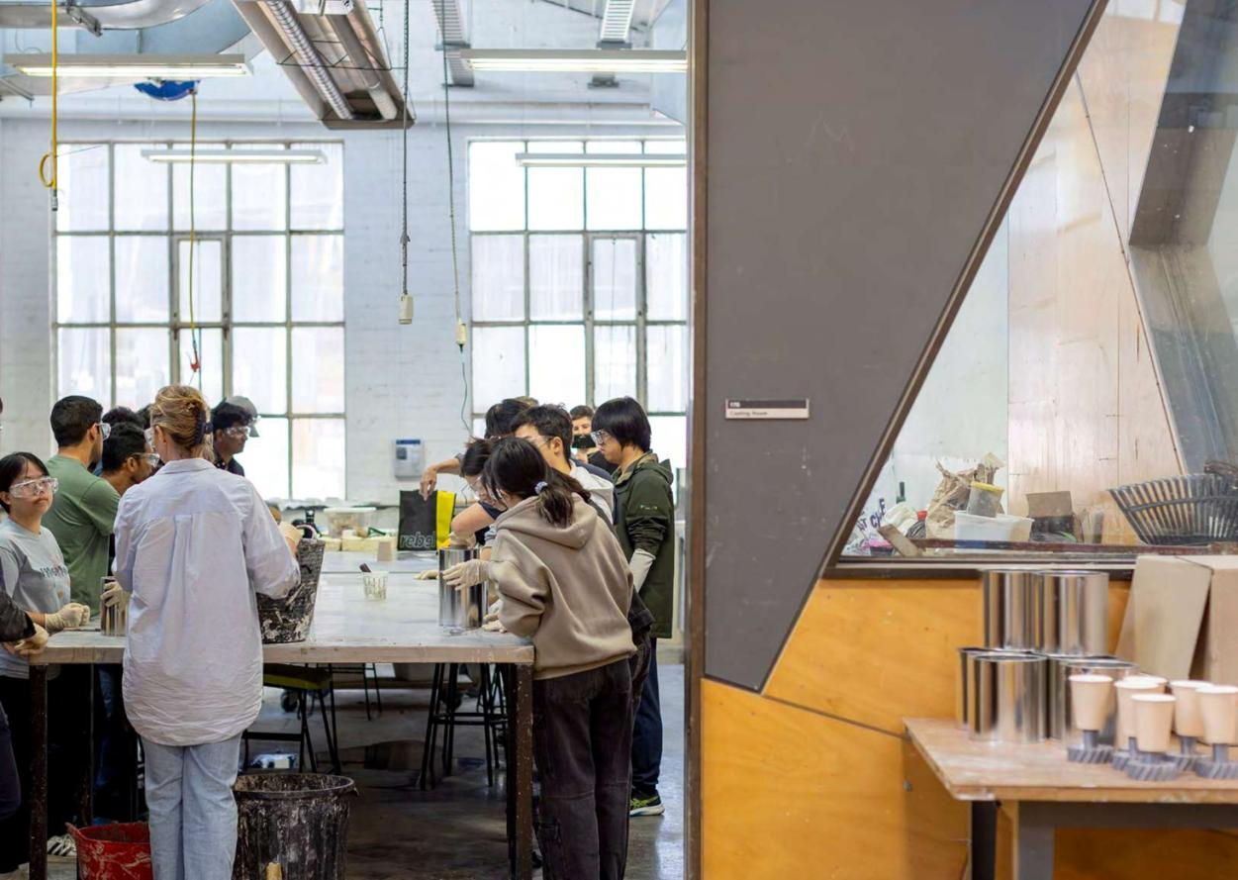
Image: A class in the Victorian College of the Arts Metal Casting Lab. Copyright Michael Kai Photography

https://www.unimelb.edu.au/indigenous/acknowledgement-of-country
Diversity and Inclusion Strategy 2030, https://about.unimelb.edu.au/diversity-inclusion/strategy-and-policy, with the Anti-Racism Action Plan, Disability inclusion Action Plan, Gender Equality Action Plan, Respect at Melbourne, the Athena Swan Accreditation Program, and LGBTIQA+ Inclusion Action Plan; Murmuk Djerring Indigenous Strategy; Advancing Melbourne Globally; Advancing Students in Education; the People Strategy; and the Sustainability Plan 2030.
2022 University Diversity and Inclusion Survey; 2023 University Staff Experience Survey; 2022 FFAM Student Perspectives Project the University of Melbourne Student Union Racism at Southbank Survey; and the 2023 Making Higher Education in Music More Accessible report.
University of Melbourne Anti-Racism Action Plan 2024 - 2027, 3, https://about.unimelb.edu.au/diversity-inclusion/anti-racism-action-plan.
Murmuk Djerring Indigenous Strategy, 6, https://www.unimelb.edu.au/indigenous/murmuk-djerring.

